Kavya vichare CSE/DS SE3 Roll no -64

Experiment 4

Title
Develop a dynamic webpage where content updates on button click using JavaScript DOM.
Implement jQuery effects: hide/show elements, toggle visibility, and animate elements.
Theory:
- JavaScript and the DOM (Document Object Model):
  - The DOM is a hierarchical representation of the elements on a webpage. It allows programming languages like JavaScript to interact with the structure, style, and content of the page.
○ Using DOM methods, we can:
■ Access elements (getElementById, getElementsByClassName, querySelector)
■ Change content (innerHTML, textContent)
■ Modify attributes (setAttribute, removeAttribute)
■ Change styles dynamically (style.property)
○ Example: Changing the text of a paragraph when a button is clicked enhances user interactivity.
- Dynamic Webpage Content:

  - A dynamic webpage changes content without reloading the page.

○ Dynamic updates improve user experience by allowing real-time feedback and interactivity.

○ In this lab, content updates are achieved using document.getElementById().innerHTML to manipulate text dynamically.

○
- Introduction to jQuery:

  - jQuery is a lightweight, fast JavaScript library that simplifies:

HTML document traversal and manipulation

■ Event handling

■ Animations and effects

○ jQuery is cross-browser compatible, meaning the same code works in different browsers without modification.

Syntax Example:
$(selector).action();
○
■ $() is the jQuery function
■ selector identifies the HTML element
■ action() is the method applied (like hide(), show(), animate())
- jQuery Effects and Animations:
  - Hide/Show: Instantly hide or show elements.

○ Toggle: Switch visibility state of an element (hide → show, show → hide).
○ Animate: Allows smooth transitions of CSS properties (like height, width, opacity, margins).
○ Benefits of jQuery Effects:
■ Improves visual interactivity
■ Reduces manual CSS manipulation

■ Provides smoother user experience

- Integration of JS DOM and jQuery:

  - Using pure JavaScript allows control over element content and structur

○ Using jQuery complements JS by handling animations and effects more efficiently.

○ Combining both allows for dynamic and interactive web pages where content changes and user interactions are smooth and visually appealing.

- Applications:

  - Dynamic webpages are used in:

■ Online forms that validate inputs instantly
■ Content sliders and carousels
■ Real-time notifications
■ Interactive dashboards

Procedure
- Include jQuery CDN:
<script src="https://code.jquery.com/jquery-3.7.0.min.js"></script>
- Create HTML element:
<div id="box">Hello</div> <button id="btn">Toggle</button>
- Apply jQuery:
<script>
$('#btn').click(function(){
$('#box').toggle(500);
});
</script>

Output

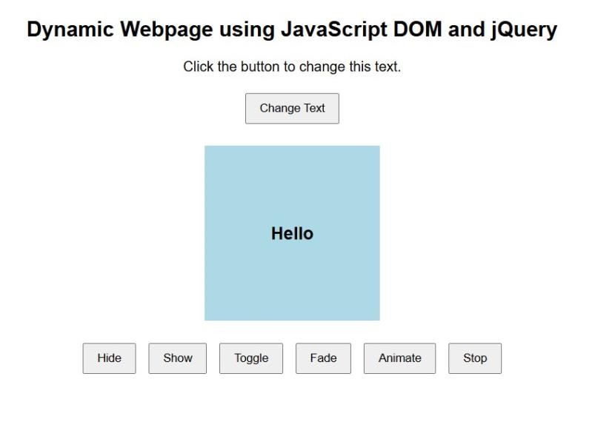

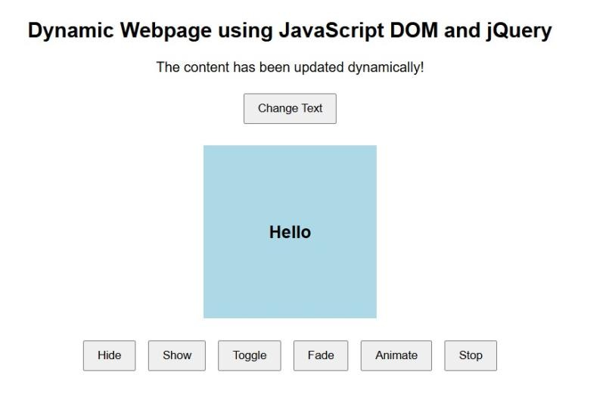

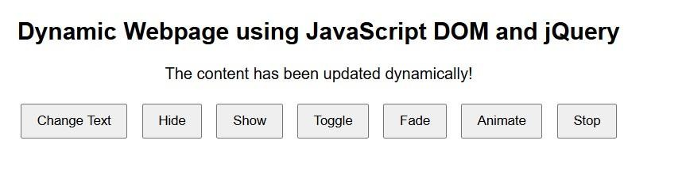

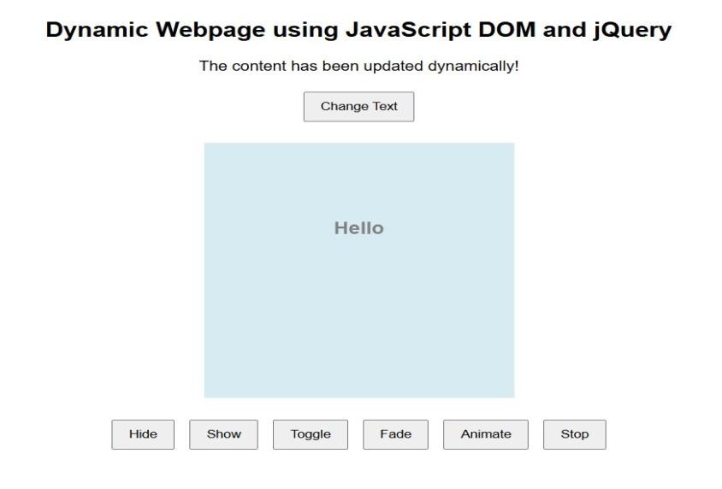

Conclusion
JavaScript DOM allows dynamic updating of webpage content in real-time. jQuery simplifies element manipulation, effects, and animations. Combining both creates interactive and visually appealing webpages, enhancing user experience. This lab demonstrated practical implementation of content updates, visibility toggling, and animations.

Question:
- What is the difference between .hide() and .toggle() in jQuery?
- How can you stop an ongoing animation in jQuery before it completes?
- How can you use jQuery to fade in and fade out an element?

21

